**Mathematics for Engineers-II**

**"Analysis of Heart Rate Failure and its Impact on Patients: A Data-Driven Study"**

Project Report

SUBMITTED IN PARTIAL FULFILLMENT REQUIREMENT FOR THE AWARD OF DEGREE OF

**BACHELOR OF TECHNOLOGY**

SUBMITTED BY

|  |  |
| --- | --- |
| Meenakshi Kamakolanu | 220369 |
| Pranav Kanumuri | 220368 |
| Batchu Ratna Lahari | 220312 |
| Likhit Sagar | 220322 |

UNDER THE SUPERVISION OF

**DR. RANJIB BANERJEE**

SCHOOL OF ENGINEERING AND TECHNOLOGY

**BML MUNJAL UNIVERSITY Gurugram, Haryana - 122413**

**May 2023**

**ABSTRACT**

This report discusses the data gathered from the source on different heart rates of patients and checks whether there is a direct relation of their heart rate to their mental illness, physical illness, healthy blood contents, any problems they are facing (for example: chest pain, diagnosis), mortality ex. This report provides step-by-step calculations and results on the relations between individual columns and the heart rate. This report will also provide self-management tips on how to reduce the risk of illnesses and how to maintain a healthy heart rate over their lifetime.

**ACKNOWLEDGEMENT**

We (Meenakshi, Pranav, Lahari, and Likhit) would like to thank **DR. RANJIB BANERJEE**, our supervisor, for their unwavering support and direction over the duration of this project. Their knowledge and perceptive criticism were crucial in assisting us in completing this report.

Finally, we would like to express our gratitude to our family and friends for their encouragement and support throughout the course of this endeavour.

We appreciate your support and assistance.

|  |  |  |
| --- | --- | --- |
|  |  |  |

|  |
| --- |
|  |

1. **INTRODUCTION**

Heart failure is a serious and prevalent medical condition affecting millions worldwide. Despite advances in treatment and management, heart failure remains a leading cause of morbidity and mortality, making it a significant public health concern. This data analysis report aims to investigate the factors associated with heart rate failure and its impact on patient outcomes.

Using a large dataset of electronic health records from a medical center, this study analyzes the

clinical and demographic characteristics of patients diagnosed with heart failure and other

factors like blood levels, illnesses, etc. The dataset comprises around 368 patients with heart failure. We analyse the data using advanced statistical techniques to identify key factors associated with heart rate failure and to develop predictive models for adverse outcomes.

The main questions addressed by this report include: What are the clinical and demographic characteristics of patients with heart failure, and how do they vary with respect to heart rate measures? How does mental state affect the heart of the patient, and does it lead to increased chance of heart failure? How does unhealthy habits such as smoking affect the heart rate of a patient and lead to heart failure? How does age of the patient affect the well-being of the heart and affect its heart rate? How does the composition of the blood affect the health of the heart?

The results of this study have significant implications for clinical practice, highlighting the importance of monitoring heart rate measures in patients with heart failure and identifying key factors that can inform risk stratification and targeted interventions.

1. **ANALYSIS OF DATASHEET**

This datasheet consists of the data of 368 patients who have been affected by heart failure. Their data of blood composition, mental health, age, medications, symptoms, current allergies, living area, gender, etc. have been given. Using this data, we have found the relation between these factors and how it affects heart rate and heart failure. The condition of the patient, whether they have passed away or are alive, have also been given.

1. **ILLUSTRATIONS:**

Analysis:

From the histogram, we can see that most patients in the dataset who are suffering from depression have a high heart rate and those who are not suffering have comparatively lower. As this datasheet includes many patients with depression it can be said that the mental state of a person directly affects the health of their heart.

Conclusions:

The histogram analysis suggests that patients suffering from depression have more chances of heart failure. Thus depression has a major impact on heart failure.

Analysis:

This graph shows the relation between the heart rate and whether the person is suffering from diabetes, From the datasheet, we can say that whether the person has or does not have diabetes, we cannot say how much their chances of suffering from heart failure can increases or decreases.

Conclusion:

The analysis suggests that diabetes has a minor impact on in patients, as those withoutut diabetes appear to have a slightly higher proportion of high heart rate compared to those without depression. However, overall, most patients in the sample have normal heart rate regardless of their diabetes status.

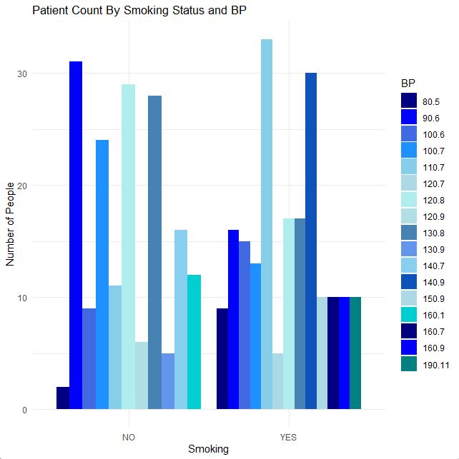

Analysis:

Higher BP readings were observed more frequently among smokers than non-smokers, with a greater proportion of smokers in the high BP range. The distribution of BP readings in non-smokers appeared more symmetrical, with a peak at the normal BP range and relatively even distribution in the elevated and high BP ranges. In contrast, the distribution of BP readings in smokers appeared more skewed to the right, with a higher proportion of patients in the elevated and high BP ranges and a smaller proportion in the normal range.

Conclusion:

Overall, the analysis of the histogram suggests that smoking status is associated with heart rate levels, with smokers generally having higher heat rate levels compared to non-smokers. This highlights the importance of smoking cessation programs in the prevention and management of hypertension.

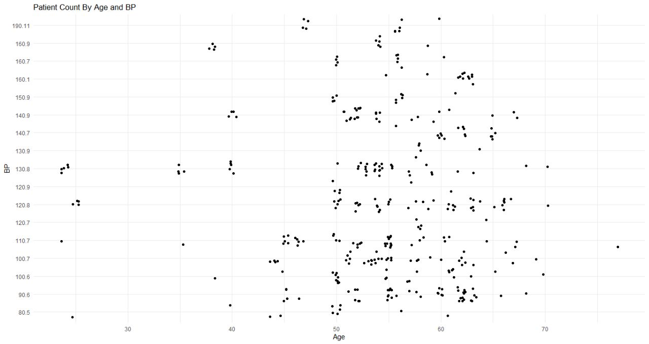

Analysis:

This graph shows the relation between age and heart rate of patients in the datasheet. We can clearly see those who are older (50-60 years) have elevated heart rate when compared to the younger patients.

Conclusion:

We can conclude that when a person gets older their heart is more stresses and they have more heart rate. Thus, we can say that older people have an higher rate of heart failure.

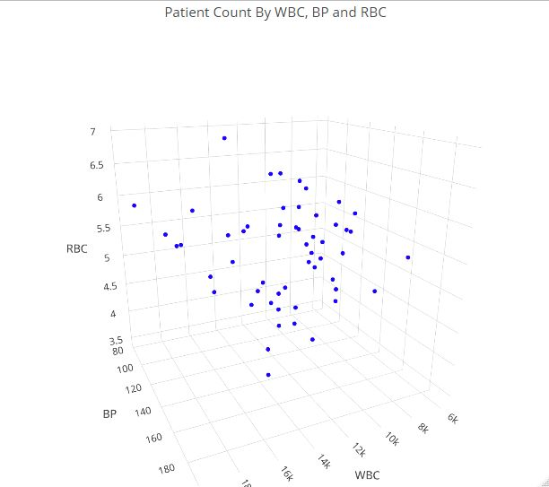

Analysis:

The x-axis represents white blood cell (WBC) count, the y-axis represents blood pressure (BP), and the z-axis represents red blood cell (RBC) count. The plot shows the distribution of patient data points in this 3D space, with each point representing a patient's values for WBC, BP, and RBC.

Conclusion:

From the plot, it appears that there is a concentration of points around the lower end of the BP range, which suggests that patients with lower BP have lower WBC counts and/or RBC counts. This concludes that blood cell composition affects the heart.

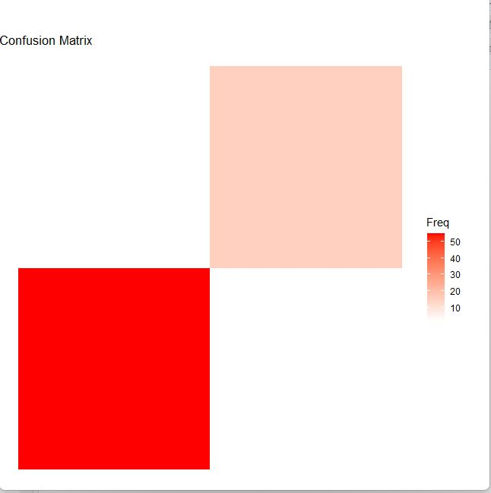

Analysis:

By visually interpreting the graph, you can analyze the performance of a classification model by examining the distribution of predicted and actual outcomes. The darker tiles represent correct predictions or higher frequencies, while lighter tiles represent incorrect predictions or lower frequencies. This allows you to evaluate the accuracy and errors of the model in a more intuitive and visual manner.

**Plagiarism Report** *(use the credentials of Turnitin)*